Screenshots and GitHub link

GitHub link- <https://github.com/Tino0917/flashcard-app.git>

Group members

Laurentino Martinez

**Ibrahim Sanni**

Yu Tze Liang

Home page

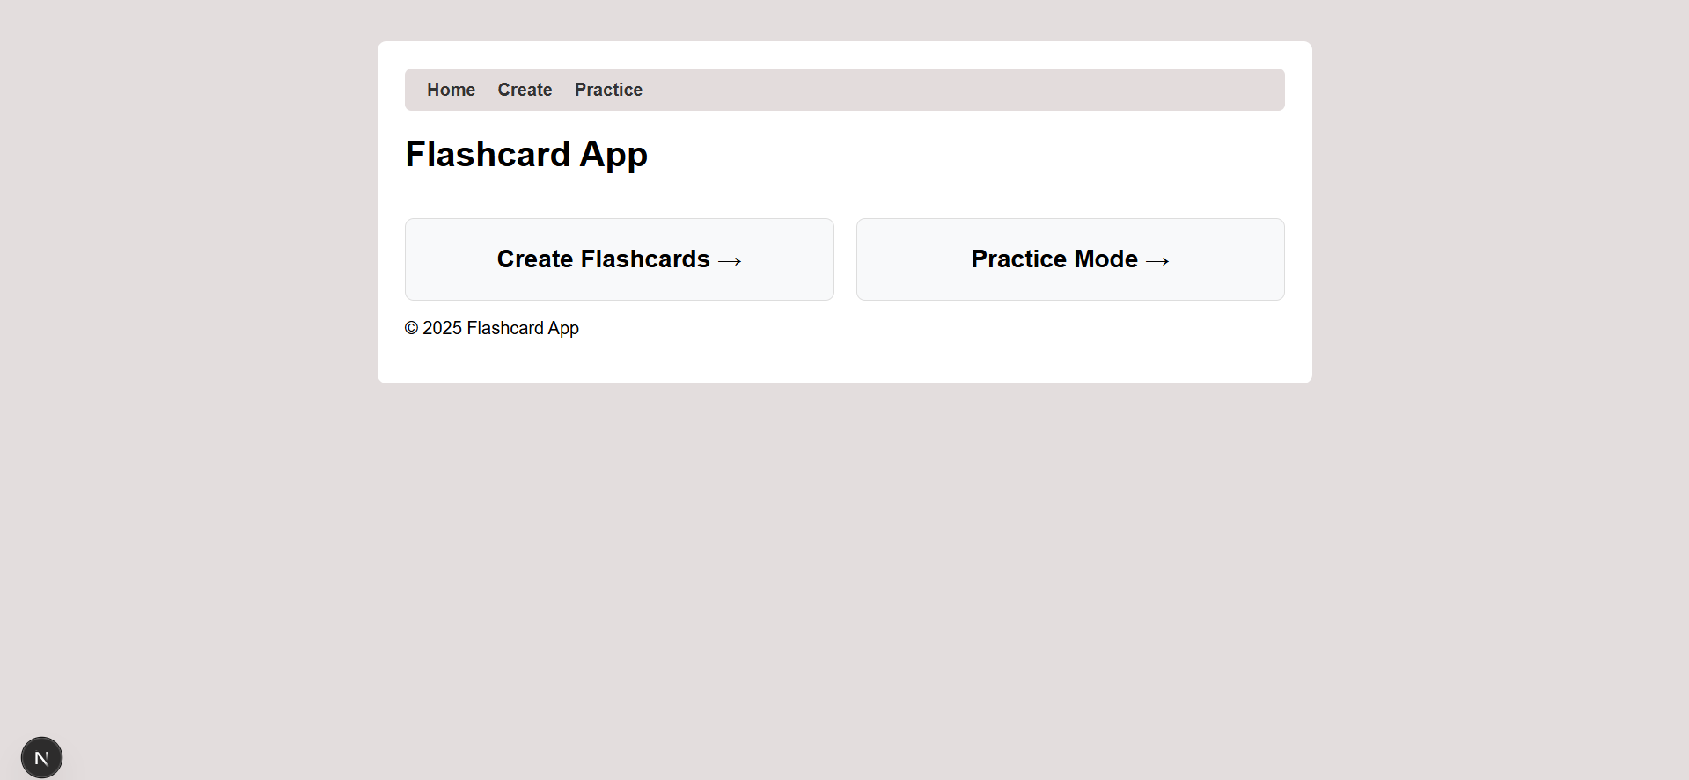

Create Page

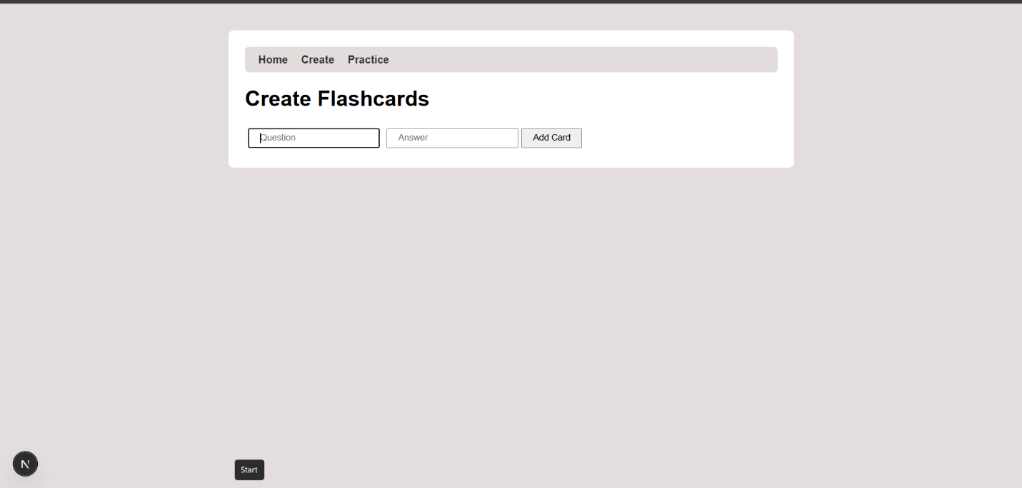

Creating a question

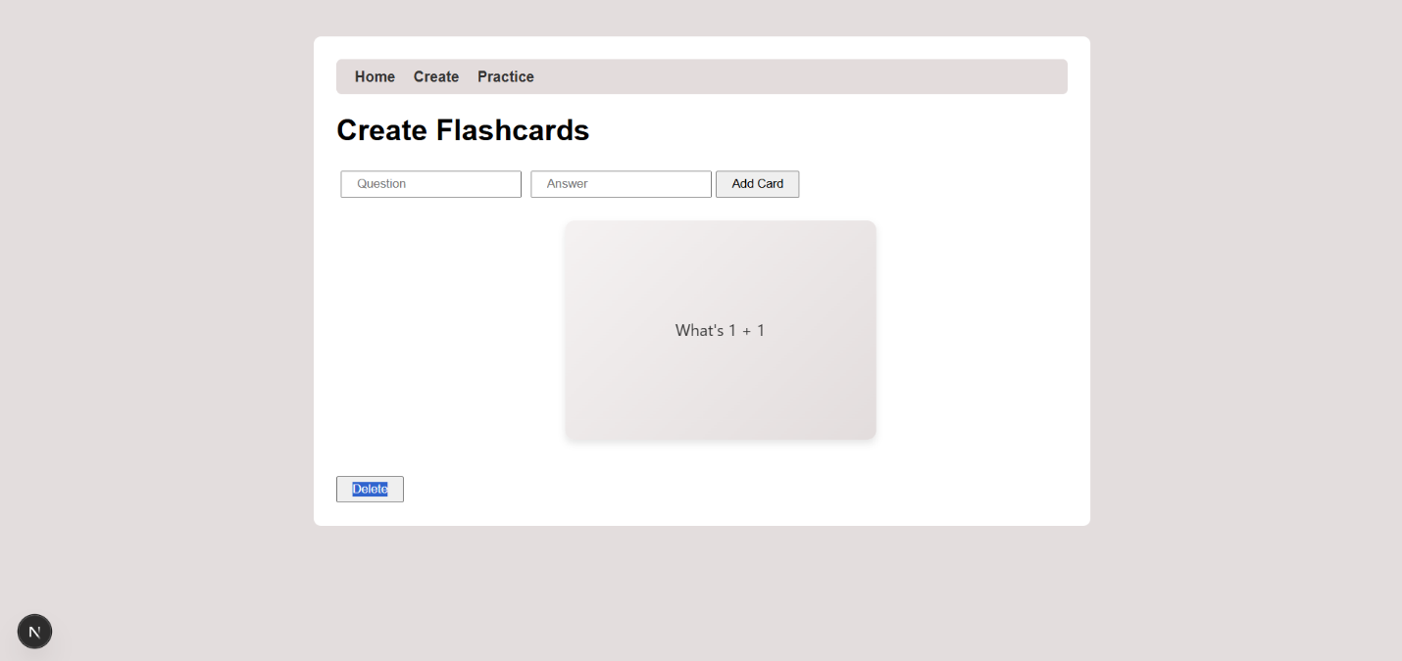

Practice page

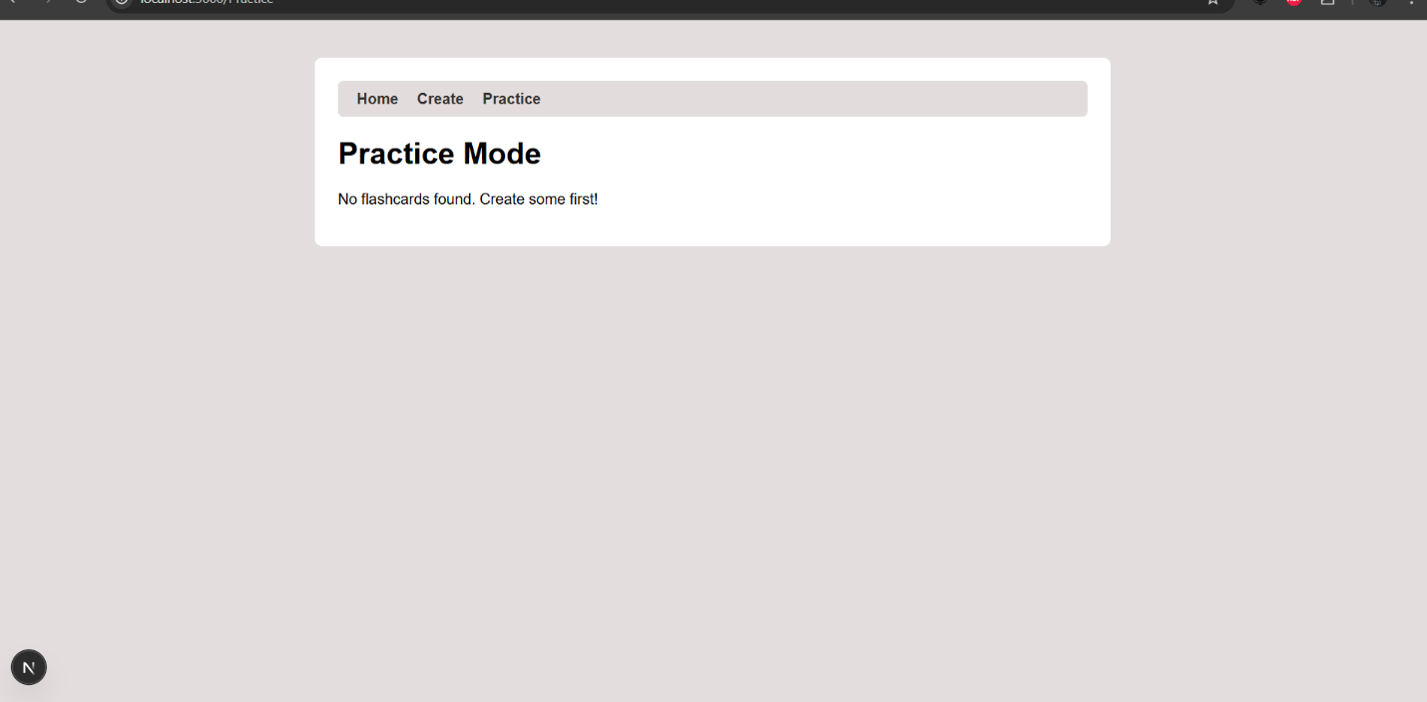

Question

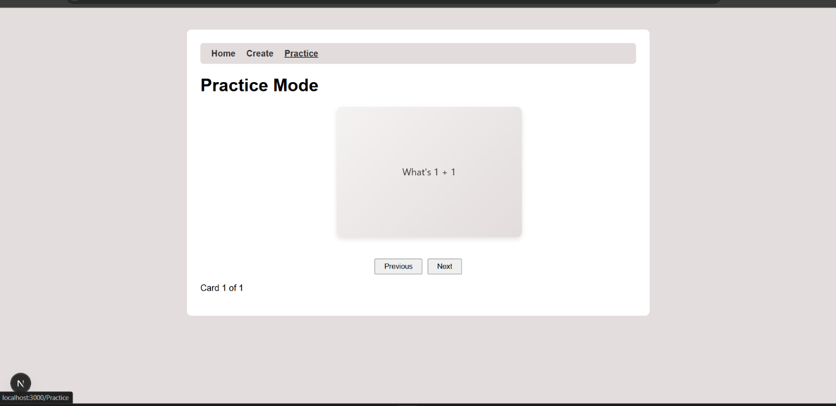

Answer

